# File permissions in Linux

## Project description

At my organization I have been instructed to review the permissions of the files and directories, identify any incorrect permissions, and make necessary changes to align with the desired authorization. The current permissions do not comply with the authorization that is required. The project revolves around examining and managing permissions for files in the /home/researcher2/projects directory, specifically for the researcher2 user. The researcher2 user belongs to the research_team group.

* In this scenario it is indicated that removing the write permissions from other users is advised for project_k.txt.
* It is noted that project_m.txt is a restricted file and should not be readable or writable by the group or other; only the user should have those permissions on this file.
* The hidden file, .project_x.txt, has been archived and should not be written to by anyone, however, the user and group should still be able to read this file.
* Only the researcher2 user should be allowed to access the drafts directory and its contents.

To complete this task, the following steps were taken:

## Check file and directory details

It is wise to understand what directory we are starting in. I begin as a user with the name researcher2 and by using the pwd command I discover that I am in the /home/researcher2 directory. Using the command ls I can list the contents within this directory and I find the /home/researcher2/projects directory. I then navigate to this directory using cd projects/. This is a relative reference as it is in relation to the current working directory. The absolute reference command to change directories would be cd /home/researcher2/projects/. Next, I need to check the details of the files and directories within this directory. To do so I will use the ls -l command. The -l attribute displays the details of the contents.

To demonstrate this process that checks the permissions of files and subdirectories in the projects directory, please refer to the screenshot below:

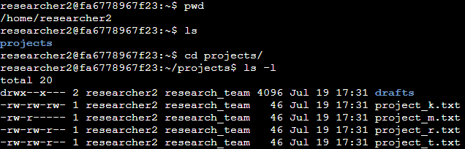

Going a step further, it will be nice to understand if there are any hidden files as well. Using the Linux command ls -la, I can list hidden files as well as their details. Refer to the screenshot below for this output:

It appears there is a .project_x.txt that is a hidden txt file. I know that this is a hidden file because it is prefaced with a period (.). I will address this further down in the writeup.

## Describe the permissions string

Directory and file permissions are represented by a 10-character string. The first character depicts whether the item is a directory (d) or a file (-). The other 9 characters indicate a specific permission or attribute. The permissions can be a combination of read (r), write (w), execute (x), or none (-). The order of this begins with the user, then the group, and finally the other. For example, if we see the following, -rwxr----x, this will mean that the file is readable, writable, and executable by the user. It is only readable by the group and only executable by the other.

Based on the output of the command above, I can identify the current permissions, I see that the drafts directory is drwx--x---, the first character indicates that it's a directory. The user has read, write, and execute permissions, the group has only execute permissions, and the other has no permissions.

## Change file permissions

Changing file permissions is done using the chmod command. In this scenario it is indicated that removing the write permissions from other users is advised for project_k.txt. In the chmod command, you can change the statuses of the three groups (user, group, and other) by removing (-), adding (+), or setting equal to (=) the desired permissions. In this situation, I will use chmod o-w project_k.txt. To see this commands output and verification of change, please refer to the screenshot below:

It is noted that project_m.txt is a restricted file and should not be readable or writable by the group or other; only the user should have those permissions on this file. Knowing this and seeing the output above, I can see that this is not conforming. The other has no permissions to this file, but the group has read only permissions. This must be changed with the chmod g-r project_m.txt command. To see this output, please refer to the image below:

## Change file permissions on a hidden file

I have already identified the hidden file in the “Check file directory and details” section. This file has been archived and should not be written to by anyone, however, the user and group should still be able to read this file. The command I want to use in this scenario is chmod u-w,g-w,g+r .project_x.txt. Please refer to the screenshot below for reference: 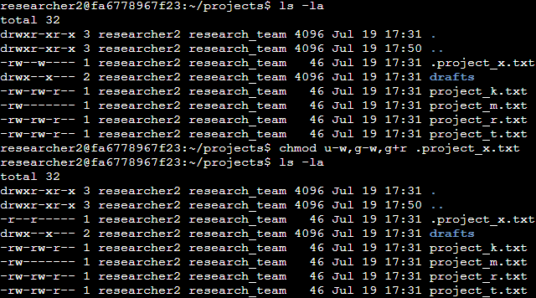

## Change directory permissions

To change directory permissions, let’s first check where I am and navigate to the /home/researcher2/projects directory. Only the researcher2 user should be allowed to access the drafts directory and its contents. Based on our previous outputs I can see that the group permissions need to be removed. To change this to be consistent with the requirement, I will use chmod g-x drafts command. Please refer to the below screenshot for this process:

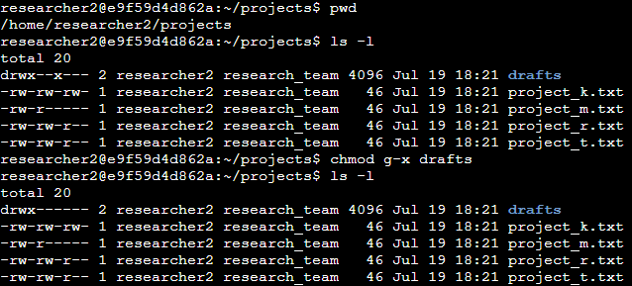

## Summary

In this project, I used Linux commands to configure and manage file permissions for a specific directory. I checked and modified file permissions in the projects directory for the researcher2 user. By examining and adjusting permissions, I ensured that only authorized individuals had access to specific files and directories. This project provided practical hands-on experience in configuring file permissions on a Linux system. Through this project, I gained valuable skills in managing authorization and ensuring the protection of resources, which is crucial for maintaining a secure and reliable computing environment.